

National Textile University
Department of Computer Science
Subject: Operating System

Submitted to: Sir Nasir Mahmood

Submitted by: Nimra Tanveer

Reg number:23-NTU-CS-1201

Assignment No.1

Semester:5th

Home task 01

Task 1 Part A: WSL2 & Ubuntu Setup:
Update Ubuntu environment:
- I do the installation of WSL2 and Ubuntu successfully on my system.
- I check that the Ubuntu terminal opens and works properly.

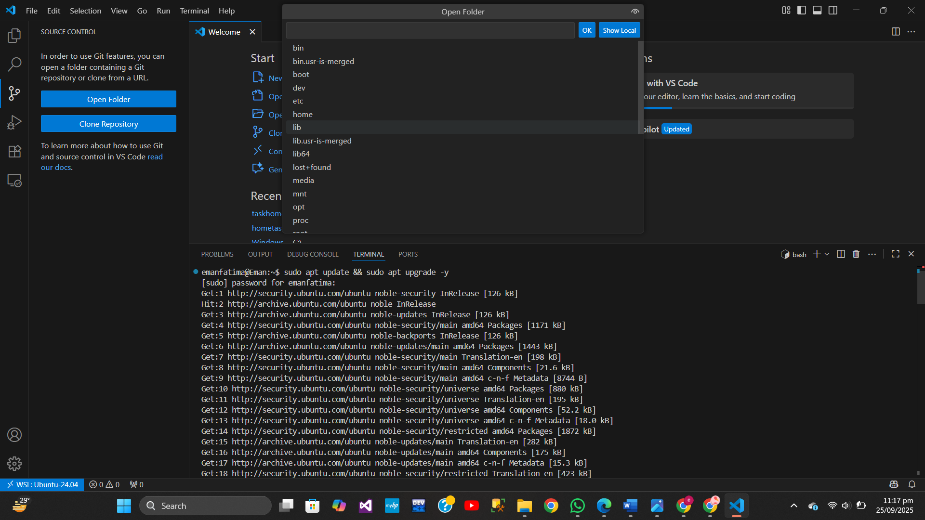

Part B: Git & GitHub SSH Setup
- Configure Git Set your name and email:
• I do the Git configuration by setting my username and email.

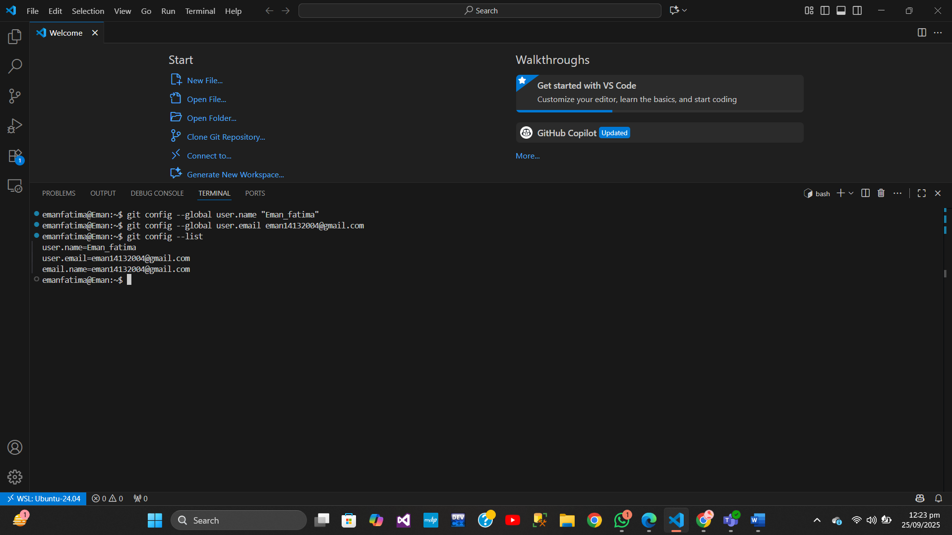

2.Generate SSH Keys And 3. Test Connection:
• I generate SSH keys and test the connection with GitHub successfully.

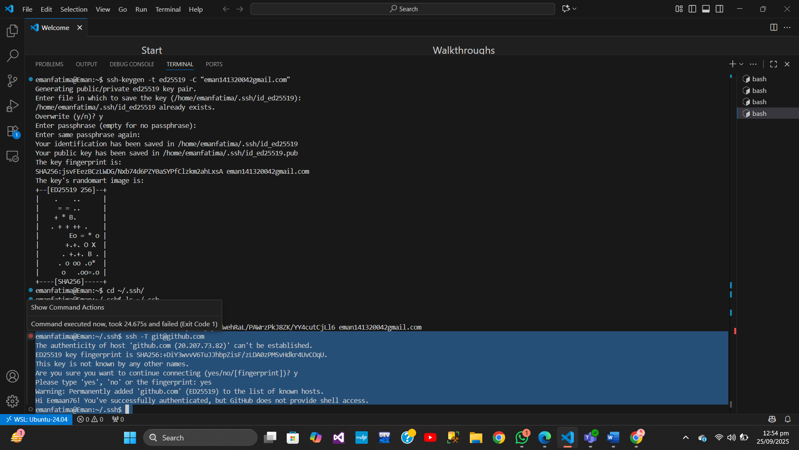

Task 3:

Step 1: Install Build Toolsand gcc version check :
- I do the installation of build tools and gcc compiler without any errors.
- Then I check the gcc version to confirm the compiler is installed correctly.

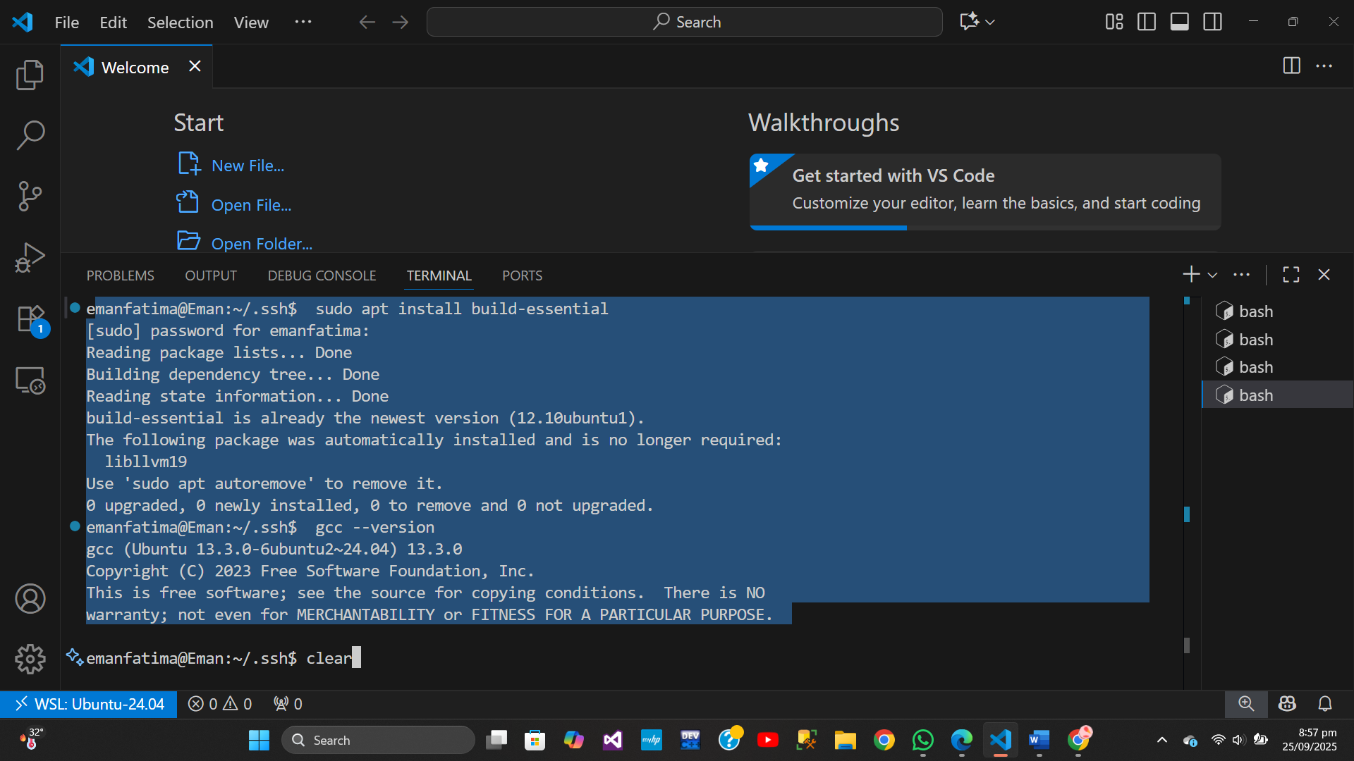

Step 2: How to run a C Program and resukt showing :
- I write, compile, and run a simple C program in Ubuntu successfully.
- After that I check the output to confirm that the program runs without errors.

